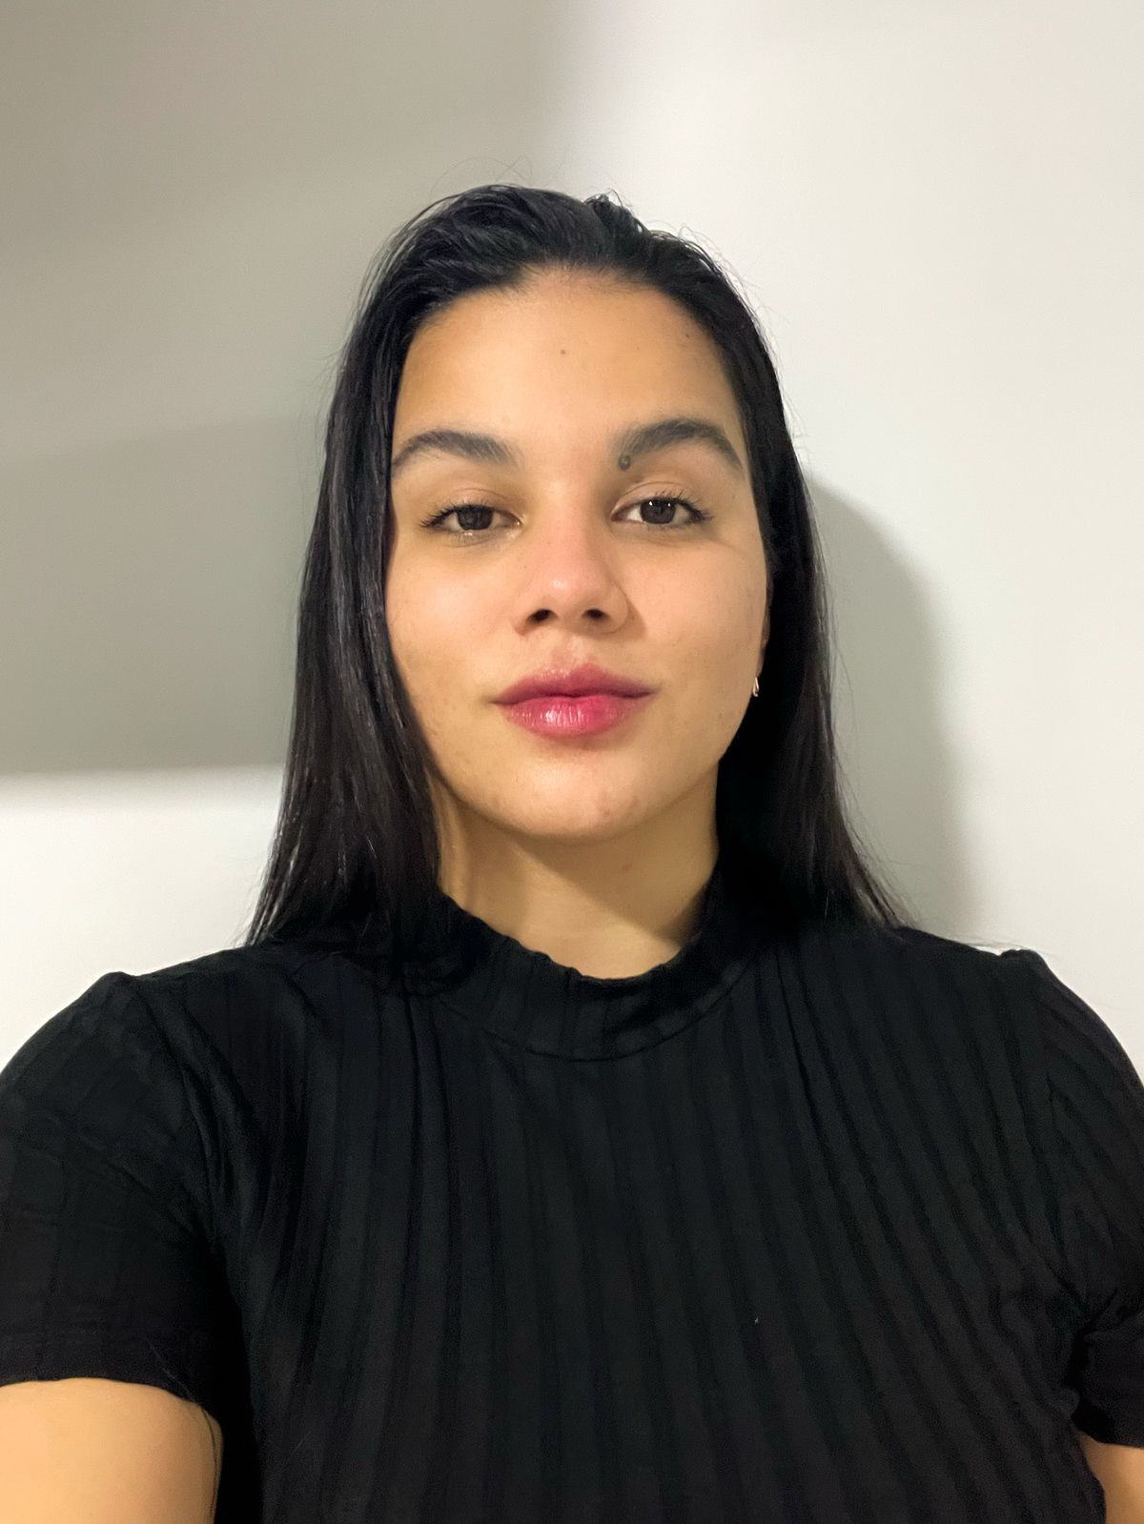
ALEXYA MORAES VIANA DOMINGUES
Full Stack Software Engineer (Java | C#)
+55 67 98413-7346 | alexyavianaa@gmail.com | Campo Grande, MS, Brazil | Linkedin | Github | Credly

Professional Summary
Full Stack Software Engineer with 3+ years of professional experience across the full software development lifecycle, building and maintaining large-scale government systems (housing, legal and document management) in Java and C#. Experienced in modernizing legacy Java 6/7/8 applications to Java 25 (LTS), improving reliability, memory efficiency and maintainability. Background in financial workflows, including boleto generation and bank file integrations in XML. Strong practitioner of object-oriented design, TDD, code reviews and CI/CD, working in Agile teams.

Technical Skills
Languages: Java (6 to 25), C#, JavaScript, SQL
Frameworks & Libraries: Spring Boot, .NET Framework, ZK Framework, Angular, React, Razor Templates
Databases: PostgreSQL, Oracle, SQL Server
DevOps & Tools: GitLab CI/CD, Azure DevOps, Azure Pipelines, Docker, Gradle (Kotlin DSL), Git
Practices: Object-Oriented Design, TDD, Code Review, Pair Programming, Scrum, Kanban

Professional Experience
Agetec | Full Stack Software Engineer April 2025 – Present | Campo Grande, MS
- Drove the migration of legacy government systems from Java 6/7/8 to Java 25 (LTS), improving long-term maintainability and security posture; replaced manually managed .jar files with dependencies resolved from Maven Central via Gradle Kotlin DSL (gradle.kts).
- Redesigned document upload and processing pipelines (eDoc & Leisweb) to stream files directly to disk via 8 KB chunked buffers instead of buffering full byte arrays (byte[]) in memory, capping single HTTP document payloads at 30 MB; reduced peak JVM heap memory usage by over 60% and eliminated container OutOfMemory crashes under heavy load.
- Implemented a streaming MD5 hashing strategy for file deduplication on disk for uploads up to 100 MB, eliminating redundant storage and I/O overhead; integrated an asynchronous OCR service pipeline combining sub-50ms native PDF text extraction with Tesseract OCR fallback.
- Designed and delivered standalone systems and high-impact features that automate public administration workflows.
- Optimized large relational databases (Oracle and PostgreSQL): modeled tables for new modules, tuned complex multi-join queries, and created targeted B-tree and text-search indexes, reducing query execution times from 30+ seconds down to under 2 seconds.
- Built and optimized complex UIs with ZK Framework and Angular, following internal Design Systems and accessibility requirements.
- Implemented and maintained GitLab CI/CD pipelines and Docker containerization, shortening deployment cycles.
- Stack: Java, Spring Boot, ZK, Angular, Docker, GitLab CI/CD, PostgreSQL, Oracle.
Digix | Full Stack Software Engineer January 2023 – October 2024 | Remote
- Owned maintenance and new feature development across the full lifecycle of a statewide housing management platform in C# (.NET) and Razor, covering internal systems (about 200 internal users) and public-facing systems (applications, registration and public access) serving citizens across the state of Mato Grosso do Sul.
- Built complex modules for user registration, social classification algorithms and financial administration for real estate financing, including new features and business rule changes.
- Maintained boleto generation, a public portal for citizens to download their boletos, and bank file integration, producing XML files that follow each bank's expected layout and standard.
- Ensured code quality and reliability through TDD and active participation in code reviews.
- Managed CI/CD with Azure Pipelines and proactively monitored the system to detect and resolve production issues.
- Stack: C#, .NET, SQL Server, Azure DevOps, Razor.
Digix | Full Stack Development Intern September 2021 – December 2022 | Remote
- Supported back-end and front-end development of housing systems and implemented client-requested changes alongside senior engineers in an Agile environment.
- Wrote SQL queries and handled production data to support Business Intelligence and reporting.
Other: Customer Support Intern, Tribunal de Justiça de MS (TJMS), 2018–2019: technical support and database permission management for internal systems.

Education
Bachelor's Degree in Software Engineering, Universidade Federal de Mato Grosso do Sul (UFMS) | 2016 – 2022
Postgraduate Degree in Computing and Information and Communication Technologies (ICT): Cybersecurity – Threat Detection and Protection of IT and Communication Systems, Faculdade Iguaçu
Postgraduate Degree in Computing and Information and Communication Technologies (ICT): Digital Game Development, Faculdade Iguaçu

Certifications & Courses
Endpoint Security (Cisco Networking Academy, 27h) | Agile Flow Metrics Workshop | Team Dynamics Workshop (Psychological Safety and Conflict Management)

Languages
Portuguese: Native | English: Professional Proficiency (Business and Conversation)

